SNOW FLAKE
Verification of Snowflake Database, Schema, Warehouse, and User Role

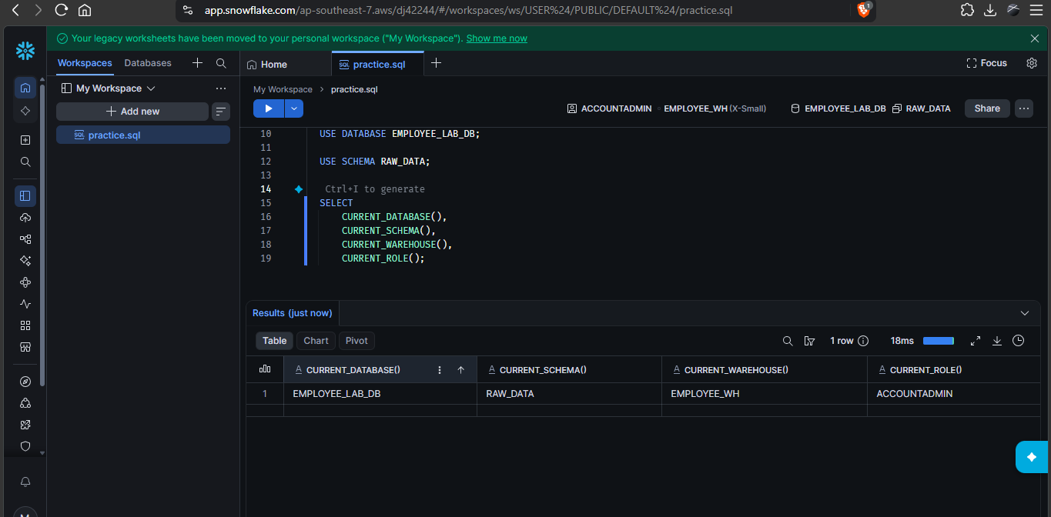

Previewing and Validating the CSV File in the First Internal Stage

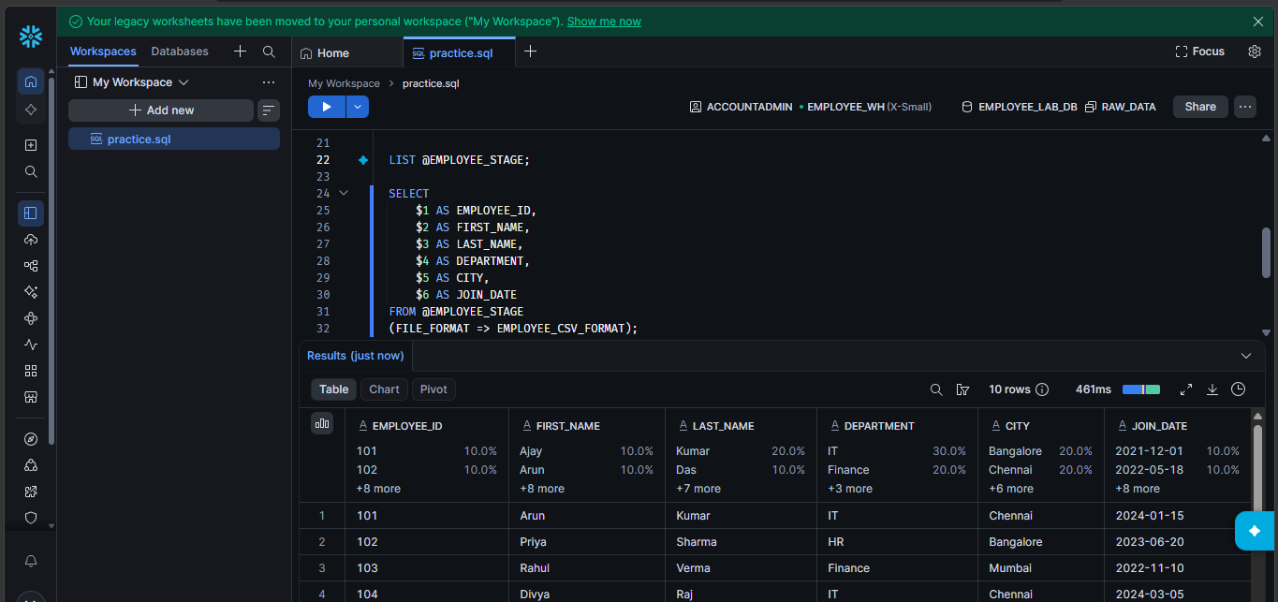

Creation of the Raw Employee Table with Appropriate Column Definitions
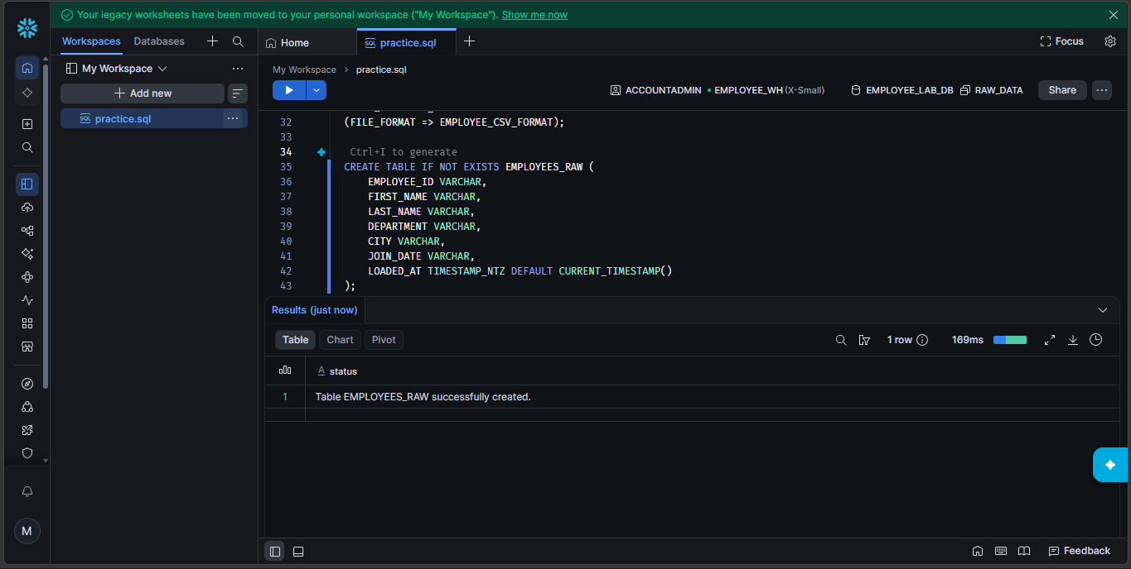

Identifying the CSV Column Count Mismatch During Initial Data Loading

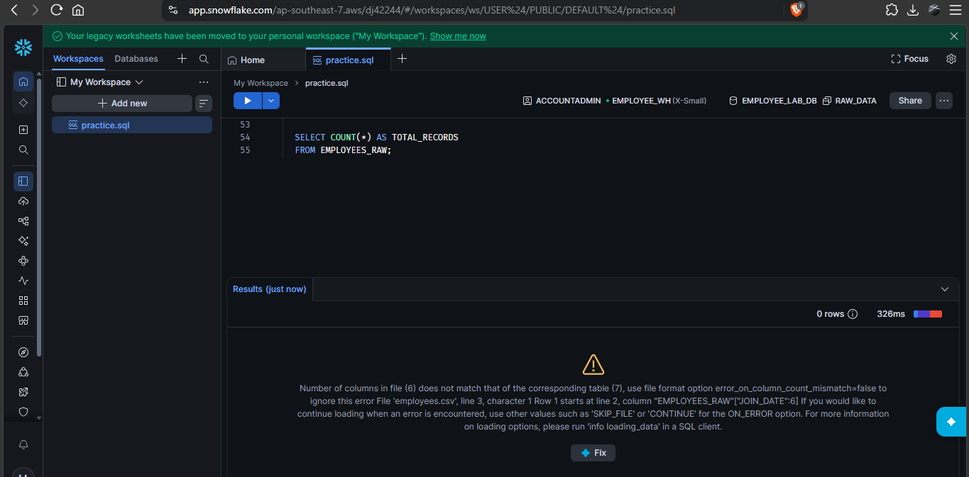

Verification of Successfully Loaded Records in the Raw Employee Table

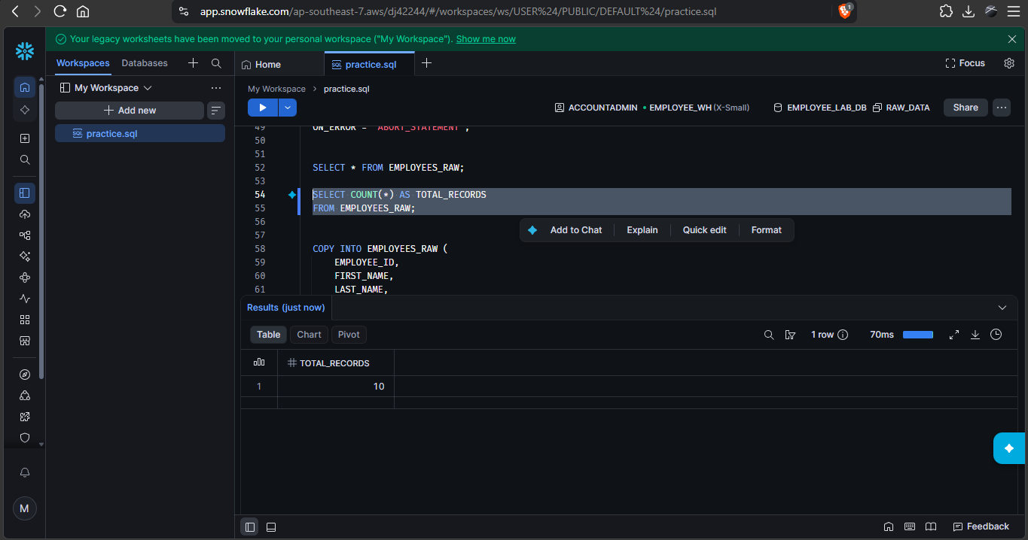

Reviewing COPY INTO Execution History and Data Loading Status

Creation of the Second Internal Stage – EMPLOYEE_CLEAN_STAGE
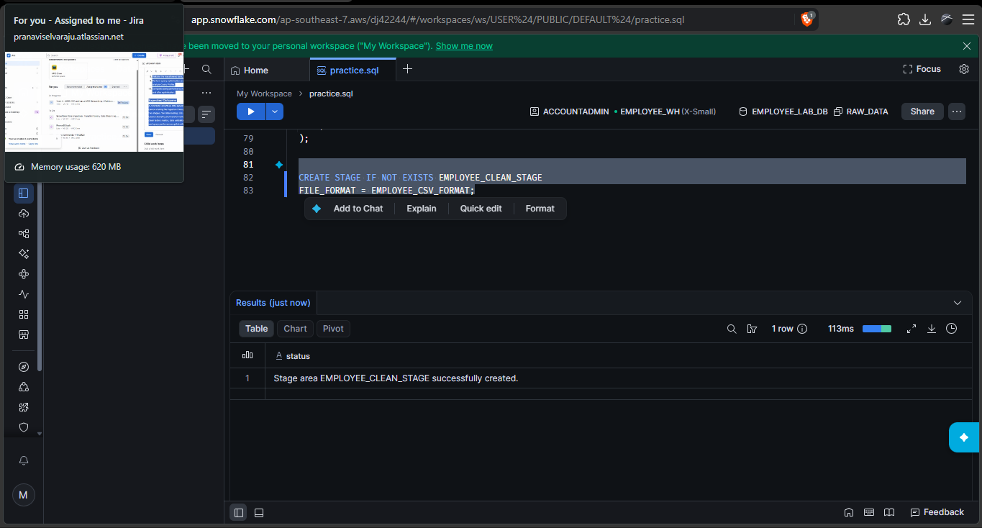

Validating and Previewing CSV Data from the Second Internal Stage

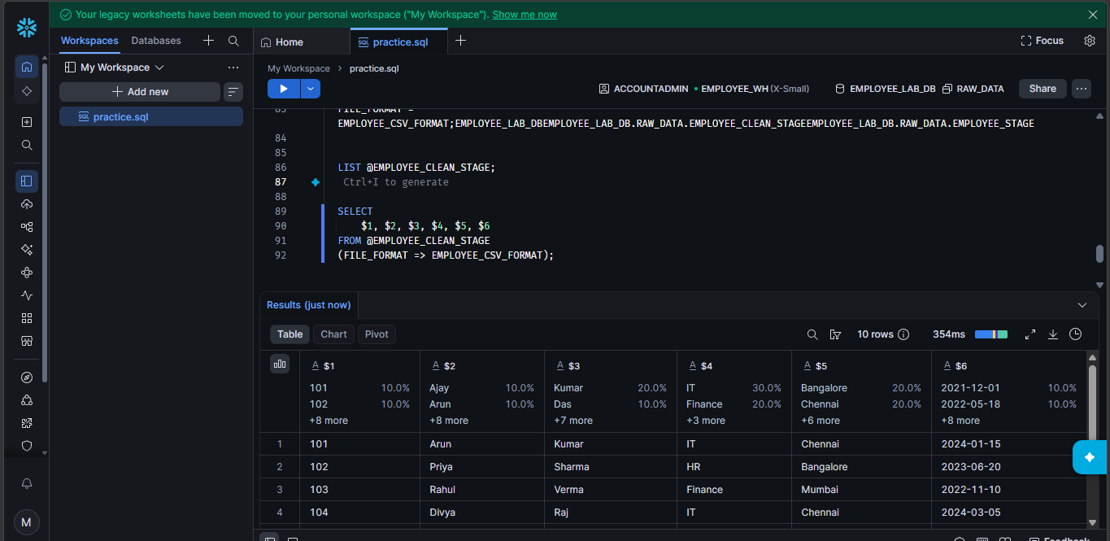

Verification of Record Count in the Clean Landing Table

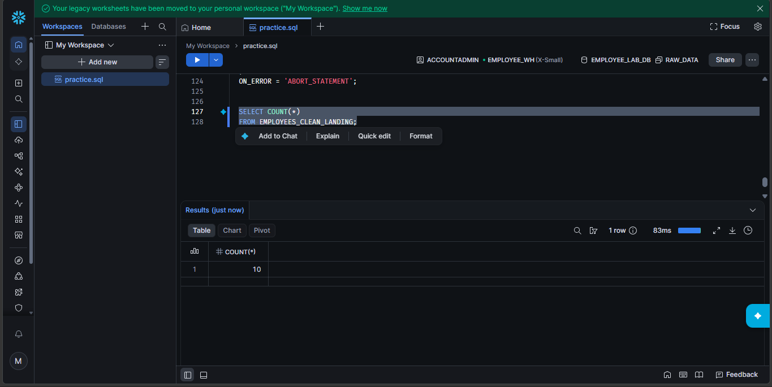

Creation and Verification of the Transformed Employee Clean Table

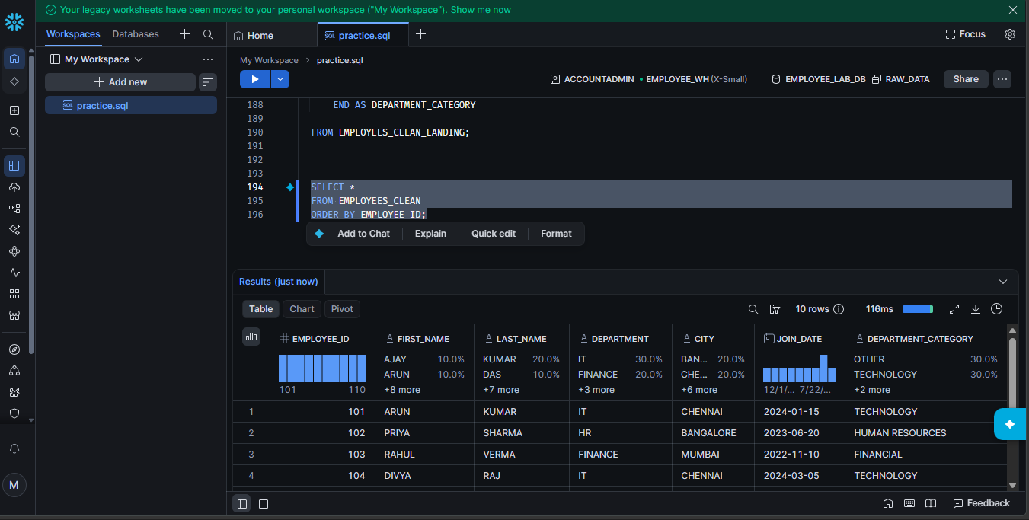

Employee Categorization Using CASE Statements and Aggregate Queries
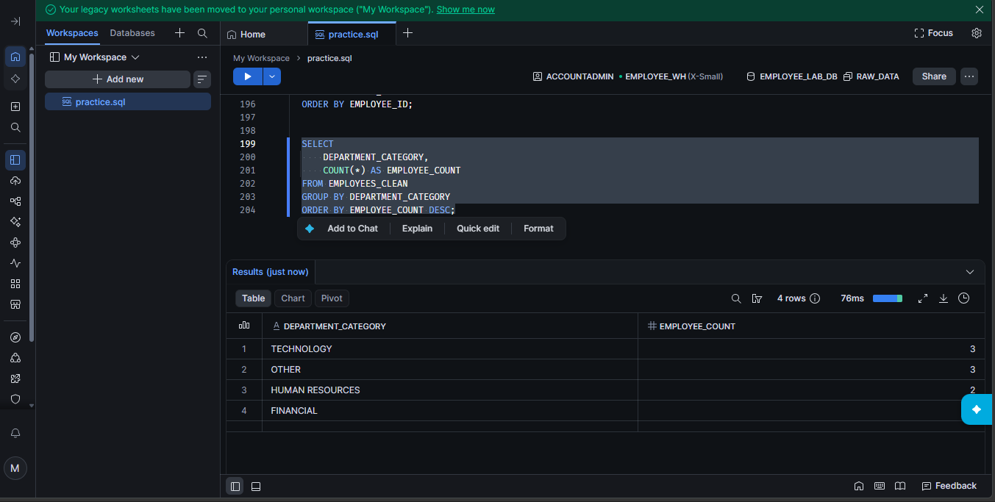

Data Quality Validation and Identification of Invalid Records

Query Optimization Using Column Selection and Efficient Filtering

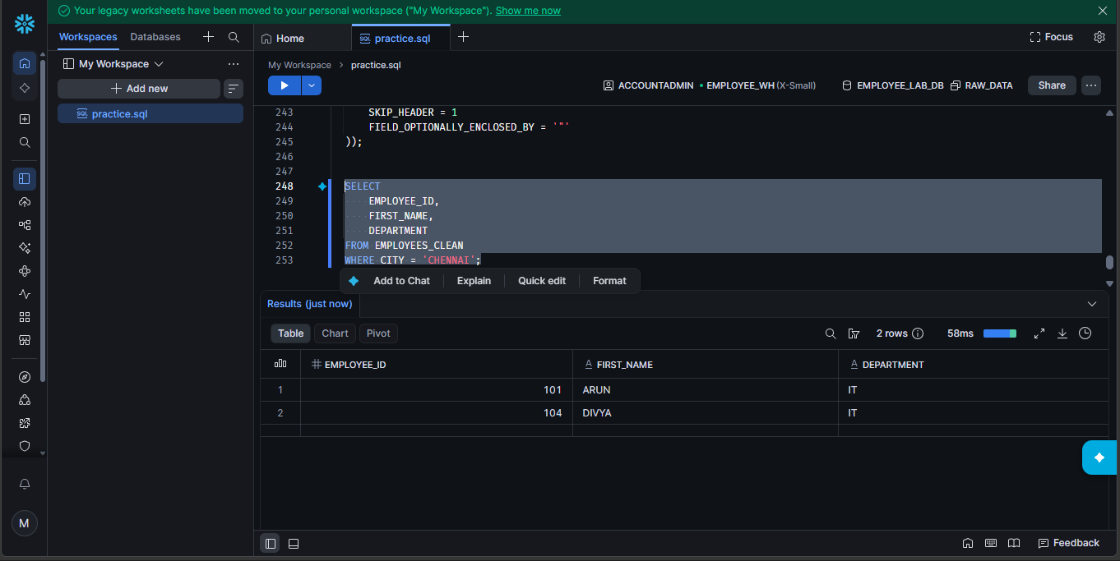

Final Validation and Record Count Comparison Across Raw and Clean Tables


